**Section -2-sanke box creation project:**

1.**class for creation of order:**

**Code:**

// Box.java

public class Box {

private String boxId;

private String dimensions;

private String materialType;

// Constructor

public Box(String boxId, String dimensions, String materialType) {

this.boxId = boxId;

this.dimensions = dimensions;

this.materialType = materialType;

}

// Properties

public String getBoxId() {

return boxId;

}

public void setBoxId(String boxId) {

this.boxId = boxId;

}

public String getDimensions() {

return dimensions;

}

public void setDimensions(String dimensions) {

this.dimensions = dimensions;

}

public String getMaterialType() {

return materialType;

}

public void setMaterialType(String materialType) {

this.materialType = materialType;

}

// Behaviors

public void assembleBox() {

// Logic to assemble the box

System.out.println("Box assembled: " + boxId);

}

public void packBox() {

// Logic to pack the box

System.out.println("Box packed: " + boxId);

}

public void sealBox() {

// Logic to seal the box

System.out.println("Box sealed: " + boxId);

}

}

// Snake.java

public class Snake {

private String snakeId;

private String species;

private double length;

// Constructor

public Snake(String snakeId, String species, double length) {

this.snakeId = snakeId;

this.species = species;

this.length = length;

}

// Properties

public String getSnakeId() {

return snakeId;

}

public void setSnakeId(String snakeId) {

this.snakeId = snakeId;

}

public String getSpecies() {

return species;

}

public void setSpecies(String species) {

this.species = species;

}

public double getLength() {

return length;

}

public void setLength(double length) {

this.length = length;

}

// Behaviors

public void feedSnake() {

// Logic to feed the snake

System.out.println("Snake fed: " + snakeId);

}

public void handleSnake() {

// Logic to handle the snake safely

System.out.println("Snake handled: " + snakeId);

}

public void inspectSnake() {

// Logic to inspect the snake

System.out.println("Snake inspected: " + snakeId);

}

}

// Main.java

public class Main {

public static void main(String[] args) {

// Creating instances of each object

Order order1 = new Order("001", "John Doe, 123 Main St", "2024-08-08");

Box box1 = new Box("B001", "30x30x30", "High Quality Cardboard");

Snake snake1 = new Snake("S001", "Python", 1.5);

// Demonstrating behaviors

order1.createOrder();

order1.updateOrder("Jane Doe, 456 Elm St", "2024-08-09");

order1.cancelOrder();

box1.assembleBox();

box1.packBox();

box1.sealBox();

snake1.feedSnake();

snake1.handleSnake();

snake1.inspectSnake();

    }

}

Output:

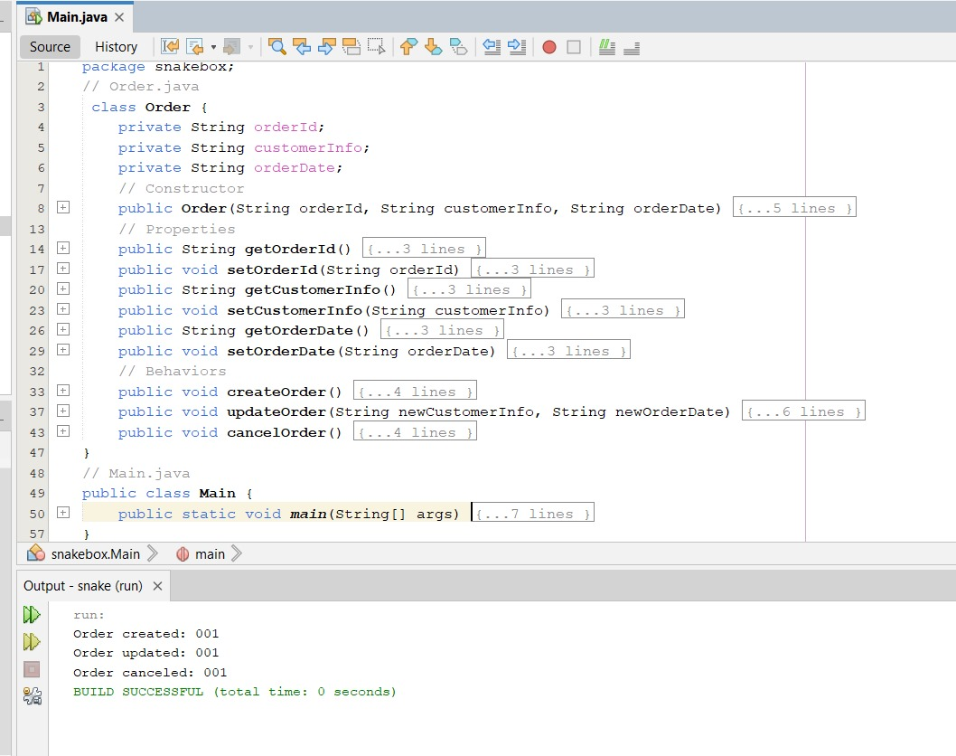

**2.class for creation of boxes:**

**Code:**

package snakebox;

// Box.java

class Box {

private String boxId;

private String dimensions;

private String materialType;

// Constructor

public Box(String boxId, String dimensions, String materialType) {

this.boxId = boxId;

this.dimensions = dimensions;

this.materialType = materialType;

}

// Properties

public String getBoxId() {

return boxId;

}

public void setBoxId(String boxId) {

this.boxId = boxId;

}

public String getDimensions() {

return dimensions;

}

public void setDimensions(String dimensions) {

this.dimensions = dimensions;

}

public String getMaterialType() {

return materialType;

}

public void setMaterialType(String materialType) {

this.materialType = materialType;

}

// Behaviors

public void assembleBox() {

// Logic to assemble the box

System.out.println("Box assembled: " + boxId);

}

public void packBox() {

// Logic to pack the box

System.out.println("Box packed: " + boxId);

}

public void sealBox() {

// Logic to seal the box

System.out.println("Box sealed: " + boxId);

}

}

// Main.java

public class Main {

public static void main(String[] args) {

Box box1 = new Box("B001", "30x30x30", "High Quality Cardboard");

box1.assembleBox();

box1.packBox();

box1.sealBox();

    }

}

**Output:**

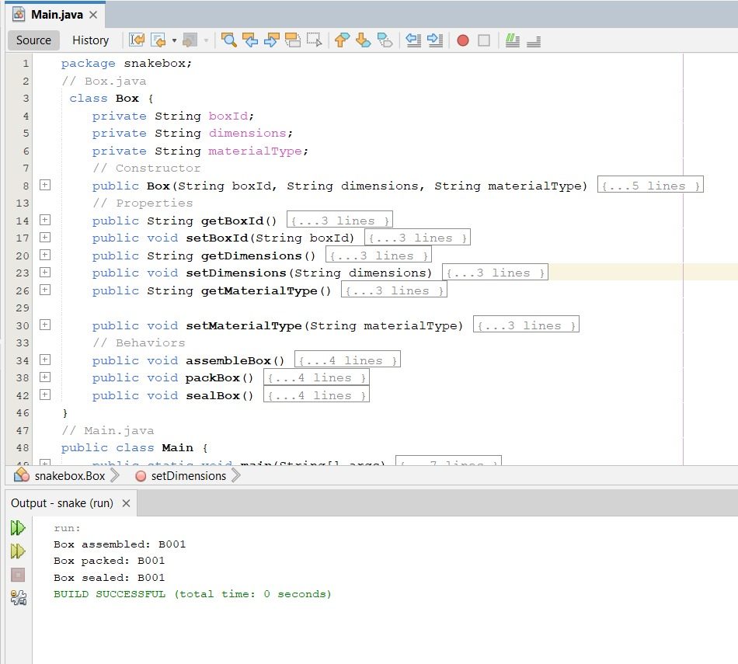

**3.class for creation of snake :**

**Code**:

package snakebox;

// Snake.java

public class Snake {

private String snakeId;

private String species;

private double length;

// Constructor

public Snake(String snakeId, String species, double length) {

this.snakeId = snakeId;

this.species = species;

this.length = length;

}

// Properties

public String getSnakeId() {

return snakeId;

}

public void setSnakeId(String snakeId) {

this.snakeId = snakeId;

}

public String getSpecies() {

return species;

}

public void setSpecies(String species) {

this.species = species;

}

public double getLength() {

return length;

}

public void setLength(double length) {

this.length = length;

}

public void feedSnake() {

System.out.println("Snake fed: " + snakeId);

}

public void handleSnake() {

System.out.println("Snake handled: " + snakeId);

}

public void inspectSnake() {

System.out.println("Snake inspected: " + snakeId);

}

}

public class Main {

public static void main(String[] args) {

Snake snake1 = new Snake("S001", "Python", 1.5);

snake1.feedSnake();

snake1.handleSnake();

snake1.inspectSnake();

    }

}

**Output:**